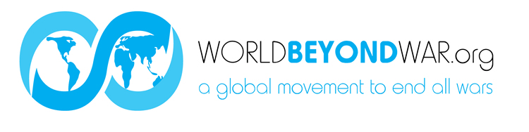

SUGGESTED DONATION: $15 Everyone can have a button!

while supplies last:

FOR A DONATION OF $50 You can also have a sky-blue scarf!

FOR A DONATION OF $75 You can also have a canvas display copy of the Kellogg-Briand Pact!

FOR A DONATION OF $100 You can also have a copy of one of these books (many of them signed by the authors) that we will send to you right away in the mail: War No More: The Case for Abolition by David Swanson
War Is A Lie, by David Swanson
When the World Outlawed War, by David Swanson
Look Not Unto the Morrow, by Robert Fantina
They Were Soldiers, by Ann Jones
The End of War, by John Horgan
Dissent: Voices of Conscience, by Ann Wright and Susan Dixon
Addicted to War, by Joel Andreas
Living Beyond War, by Winslow Myers
Transition to Peace, by Russell Faure-Brac
Shift--The Beginning of War, The Ending of War, by Dr. Judith Hand
Women, Power and the Biology of Peace, by Dr. Judith Hand
Empire, Racism & Genocide, by Robert Fantina
Civilization is Possible, by Blase Bonpane
Guerillas of Peace, by Blase Bonpane
Guerillas of Peace On the Air, by Blase Bonpane
Common Sense for the Twenty-First Century, by Blase Bonpane

LARGER DONATIONS ARE GREATLY APPRECIATED AND WILL BE HONORED ON OUR WEBSITE WITH YOUR PERMISSION

U.S. DONATIONS ARE TAX DEDUCTIBLE
WE ACCEPT:
Cash
Checks to World Beyond War
Credit Cards

