Do you believe…
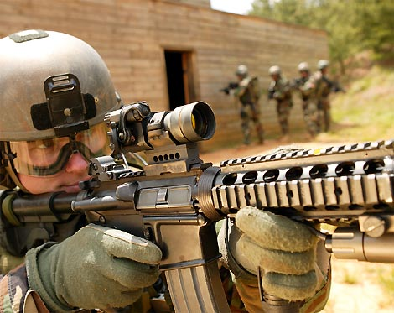
...that wars and militarism make us less safe rather than protect us?

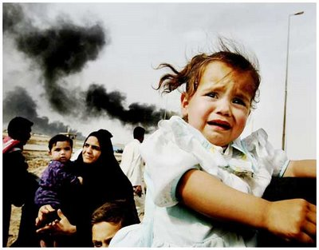

…that they kill, injure and traumatize adults and children?

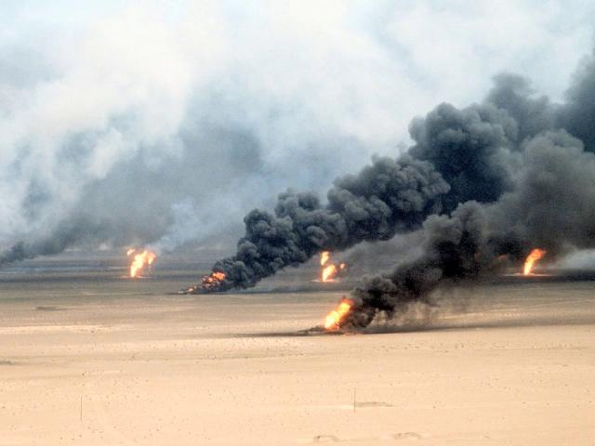

…that they severely damage the natural environment and erode civil liberties?
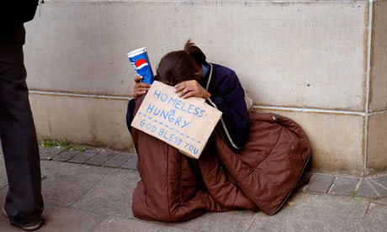

…that they drain our economies, siphoning resources from life-affirming activities?
If so, then take the pledge:

“I commit to engage in and support nonviolent efforts to end all war and preparations for war and to create a sustainable and just peace.”

