World Beyond War Calendar

Good for every year until all war is abolished and sustainable peace established.

January

January 1. This is New Year's Day and World Day of Peace. This is a good day to resolve to work for the end of all war.

January 8. On this day in 1885, A.J. Muste was born.

January 11. On this day in 2002 the United States opened its notorious prison in Guantanamo. This is a good day to oppose all imprisonment without trial.

January 14. On this day in 1892 Martin Niemöller was born.

January 15. On this day in 1929 Martin Luther King Jr. was born. The holiday, however, is celebrated on the third Monday of January. These are good opportunities to recall King's work against militarism, extreme materialism, and racism.

January 17. On this day in 1893 U.S. profiteers and Marines overthrew the government of Hawaii, beginning a long string of violent and disastrous government overthrows around the world. Also on this day in 1993 Hawaii held a major demonstration against U.S. occupation. This is a good day on which to advocate for Hawaii's liberation from the United States and from the U.S. military.

January 18. On this day in 2001 a jury in Manchester, Britain, acquitted ploughshares activists of conspiracy to damage a Trident submarine.

January 21. On this day in 1977 U.S. President Jimmy Carter pardoned all Vietnam-era draft dodgers, estimated to include hundreds of thousands. Also on this day in 1984 a women's resistance camp was set up at Volkel airbase in the Netherlands.

January 22. On this day in 1939 the atom was first split at Cambridge University.

January 23. On this day in 1974 Egypt and Israel began to withdraw troops and move away from confrontation.

January 24. On this day in 1961 the U.S. military accidentally dropped two nuclear bombs on North Carolina and was very fortunate they did not explode.

January 27. This is International Day of Commemoration in Memory of the Victims of the Holocaust. Also on this day in 1914 the U.S. Marines attacked Haiti.

January 28. On this day in 1961 the Committee for Nonviolent Action demonstrated against nuclear-armed ships in New London, Connecticut.

January 29. On this day in 2014, 31 Latin American and Caribbean nations declared a zone of peace.

January 30. This is the School Day of Nonviolence and Peace.

January 31. On this day in 2003 U.S. President George W. Bush and British Prime Minister Tony Blair met in the White House. Bush proposed several crackpot schemes for starting a war on Iraq, including painting a plane with U.N. markings, flying it low, and trying to get it shot at. Then Bush and Blair held a press conference at which they claimed to be doing everything they could to avoid a war. This is a good day on which to remember that if war were really a last resort there would never be any war.

February

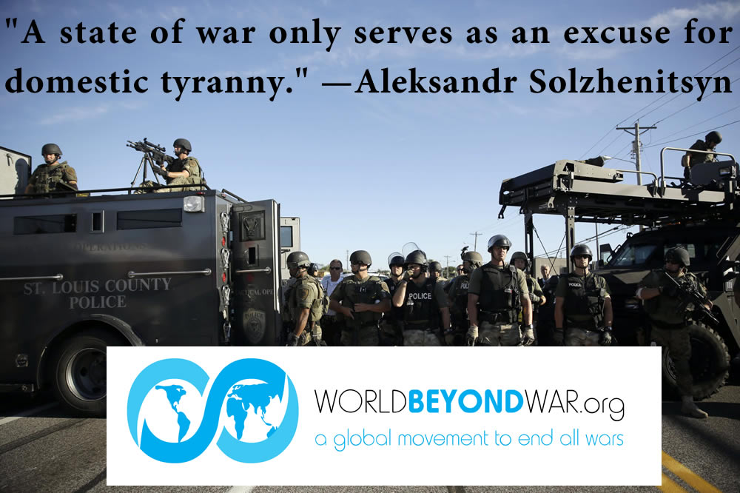

February 11. On this day in 1990 Nelson Mandela was freed from prison. He went on to play a key role in the official ending of Apartheid in South Africa. This is a good day to celebrate nonviolent action, diplomacy, reconciliation, and restorative justice.

February 15. On this date in 1898 the U.S.S. Maine blew up in Havana harbor and the United States baselessly accused Spain, and refused Spain's proposal for an independent investigation, thus providing a false cause for an imperial war on Cuba, the Philippines, and various Pacific islands. Also on this date in 2003, the world protested the threatened U.S.-led assault on Iraq in what was the largest single day of public protest in history. As a result, many nations opposed the war, and the United Nations refused to sanction it. The United States proceeded anyway, in violation of the law, common sense, and human decency, resulting in the destruction of the Iraqi nation. This is a good day to educate the world about war lies and war resistance.

February 17. On this day in 1993, leaders of the 1989 student protest in China were released.

February 19. On this day in 1942 Norwegian teachers began successful nonviolent resistance to Nazification of schools.

February 21. In this day in 1965 Malcolm X was murdered. This is a good day to study what happened.

February 27. On this day in 1933 peace activist Carl von Ossietsky was imprisoned without trial in Germany. Also on this day in 1943 Nazis began rounding up Jews in Berlin who were married to non-Jewish women. The women began a protest in Rosenstrasse that resulted in the freeing of their husbands and showed potential to grow.

February 28. On this day in 1989 the Movement to Stop All Nuclear Testing was founded in Nevada, U.S., and Semipalatinsk, USSR.

February 29. On this leap day in 2004 the United States kidnapped and deposed the President of Haiti. This is a good day on which to remember that the claim that democracies don't go to war with democracies ignores the habit of the U.S. democracy of attacking and overthrowing other democracies.

March

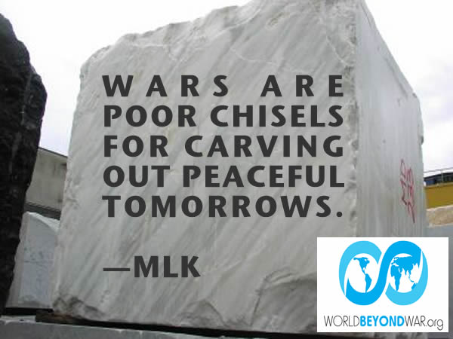

March 1. This is Nuclear Free and Independent Pacific Day, a.k.a. Bikini Day, which marks the anniversary of the U.S. Bravo nuclear bomb detonation at Bikini Atoll in 1954. The explosion gouged out a crater more than 200 feet deep and a mile across, melting huge quantities of coral which were sucked up into the atmosphere together with vast volumes of seawater. The resulting fallout caused widespread contamination in the Pacific. This is a good day for opposing nuclear weapons.

March 10. On this day in 1833 U.S. troops attacked Nicaragua. Also on this day in 1906 U.S. troops in the Moro Crater Massacre murdered over 600 mostly unarmed men, women, and children trapped in a crater on the Philippines. Also on this day in 1987 the United Nations recognized conscientious objection as a human right.

March 11. On this day in 2004, 191 people were killed by al-Qaeda bombs in Madrid, Spain. Also on this day in 2011 a nuclear power plant in Fukushima, Japan, experienced a meltdown. This is a good day to oppose nuclear energy.

March 12. On this day in 1930 Gandhi began the Salt March. This is a good day to engage in creative nonviolent resistance and construction of alternative and just systems of living.

March 14. On this day in 1879 Albert Einstein was born.

March 19. On this day in 2003 the United States attacked Iraq, launching a war that would devastate that country. This is a good day on which to advocate for reparations to the people of Iraq.

March 20. On this day in 1983, 150,000 peace rallies were held in Australia.

March 22. On this day in 1980, 30,000 people marched in Washington, D.C., against draft registration. This is a good day on which to help some draft registration forms into a recycling bin.

March 23. On this day in 1984, 1000 peace boats demonstrated against the arrival of the USS Queenfish in Auckland, New Zealand.

March 24. On this day in 1999, the United States and NATO began 78 days of bombing Yugoslavia. Fittingly perhaps, this is also International Day for the Right to the Truth concerning Gross Human Rights Violations and for the Dignity of Victims.

March 25. This is International Day of Remembrance of the Victims of Slavery and the Transatlantic Slave Trade.

March 28. On this day in 1979 a Three Mile Island nuclear reactor in Dauphin County, Pennsylvania, partially melted down. This is a good day to oppose nuclear energy.

April

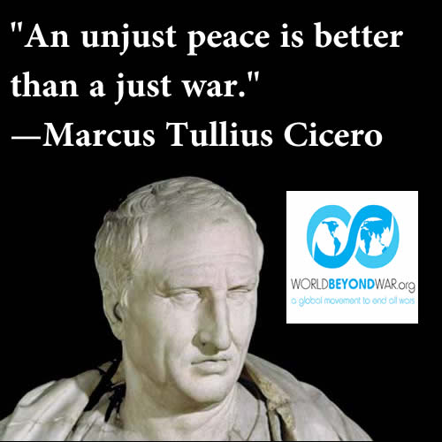

Some unpredictable day in April is the Global Day of Action Against Military Spending.

April 4. On this day in 1967 Dr. Martin Luther King Jr. spoke against the war on Vietnam. On this same day in 1968 he was murdered. This is a good day to celebrate his opposition to racism, militarism, and extreme materialism, and to study what happened. This is also International Day for Mine Awareness and Assistance in Mine Action.

April 6. On this day in 1994 the presidents of Rwanda and Burundi were assassinated. The evidence points strongly to the U.S.-backed and U.S.-trained war-maker Paul Kagame -- later president of Rwanda -- as the guilty party. This is a good day to remember that while wars cannot prevent genocides, they can cause them.

April 7. On this day in 2014 Ecuador ordered the U.S. military out of its country. This is a good day on which to demand foreign base closures.

April 12. On this day in 1935, 60,000 U.S. students went on strike against war.

April 15. On this day in 1967, 200,000 demonstrated in New York and 80,000 in San Francisco, including the first mass draft card burning. Also on this day in 1984, 250,000 people rallied for nuclear disarmament in Australia.

Tax Day in the United States is a good day to protest military spending. This day is on April 15 unless the 15th is a Friday in which case tax day is the following Monday, or if the 15th is on Saturday or Sunday then tax day is on the following Tuesday.

April 16. This is Emancipation Day in Washington, D.C. On this day in 1862 President Abraham Lincoln signed a bill ending slavery in Washington, D.C., through compensated emancipation, just as much of the rest of the world ended slavery -- without a civil war. Also on this day in 1971 U.S. veterans burned their medals at the White House to protest the war on Vietnam.

April 22. This is Earth Day, and also the birthday of Immanuel Kant.

April 25. On this day in 1974 the Carnation Revolution ended military rule in Portugal.

April 26. On this day in 1986 the Chernobyl Nuclear Plant in Ukraine, USSR, caught fire. This is a good day to oppose nuclear energy.

April 27. On this day in 1973 the British acting on behalf of the United States completed the eviction of all residents from Diego Garcia and surrounding islands. This is a good day on which to demand that they be given their islands back.

April 28. On this day in 1977 mothers held their first rally for the disappeared in Buenos Aires, Argentina.

April 29. On this date in 1975, the last Americans hastily fled Vietnam, finally ending the era of, first French, and then U.S.-occupation. This is a good day to celebrate freedom, independence, and anti-imperialism.

April 30. On this day in 1977, 1,415 people were arrested protesting at a nuclear power plant in Seabrook, New Hampshire. This is a good day to oppose nuclear power.

May

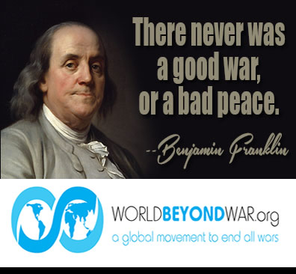

May 1. May Day is a traditional day to celebrate rebirth in the Northern hemisphere, and -- since the 1886 Haymarket incident in Chicago -- a day in much of the world to celebrate labor rights and organizing. Also on this day in 1971 massive demonstrations were held against the American War on Vietnam. Also on this day in 2003 President George W. Bush ludicrously declared "mission accomplished!" standing in a flight suit on an aircraft carrier in San Diego Harbor as the destruction of Iraq got underway. Also on that same day in 2003 the U.S. Navy finally gave in to public protest and stopped bombing the island of Vieques. Also on this day in 2005, the Sunday Times of London published the Downing Street Minutes which revealed the content of a July 23, 2002, meeting of the cabinet of the British government at 10 Downing Street. They revealed U.S. plans to go to war against Iraq and to lie about the reasons why. This is a good day to educate the world about war lies.

May 5. On this day in 2002 over 100,000 Israelis demonstrated against occupation and for a Palestinian state.

May 6. On this day in 1944 Gandhi was released from his last imprisonment.

May 7. On this day in 1915, the Lusitania was sunk by a German submarine. Germany had publicly advertised in New York prior to the ship's departure that it would be subject to attack. The ship was known to be carrying troops and weapons to be used against Germany in World War I. When President Woodrow Wilson used the sinking of the Lusitania as grounds for U.S. entry into the war, his Secretary of State William Jennings Bryan resigned in protest. For nearly a century, the U.S. media and history books claimed not to know whether the Lusitania had been carrying weapons, until the wreck of the ship was found and explored. This is a good day to educate the world about war lies.

May 8. On this day in 1944, the President of El Salvador was nonviolently overthrown. This is a good day to plot nonviolent change.

Mothers Day is celebrated on different dates around the world. In many places it is the second Sunday in May. This is a good day to read the Mother's Day Proclamation and rededicate the day to peace.

May 9. On this day in 1994 the First Assembly of Indigenous Initiative for Peace opened in Mexico City.

May 10. On this day in 1984 the International Court ordered the United States to stop mining ports in Nicaragua.

May 12. On this day in 1623 English colonists held peace talks with Powhatan leaders and poisoned the wine, killing 200 of them.

May 13. On this day in 1846, the U.S. Congress declared war on Mexico. Also on this day in 1968, a strike by students and workers led to a general strike by 10 million in Paris, France.

May 14. On this day in 1970, two students at Jackson State University were killed protesting the U.S. invasion of Cambodia.

May 15. This is Nakba Day, marking the 1948 expelling of 700,000 Palestinians from their homes, and the destruction of hundreds of towns during the creation of the state of Israel. It is also International Conscientious Objectors' Day. On this day in 1994, a stone commemorating conscientious objectors worldwide was unveiled in Tavistock Square, London.

May 16. This is Protest the Armed Forces Day.

May 17. On this day in 1968 nine people burned draft files in Catonsville, Maryland.

May 18. On this day in 1899 the Hague Peace Conference opened.

May 22. On this day in 1838, 4,000 Cherokee were killed on the trail of tears.

May 24. This is International Women's Day for Disarmament.

May 25. On this day in 1932 the Bonus Army of World War I veterans demonstrated in Washington, D.C., and were assaulted with tear gas by Douglas MacArthur.

May 26. On this day in 1637 in the Mystic Massacre, English colonists launched a night attack on a large Pequot village burning and killing all 600 to 700 residents.

May 29. On this day in 1968 the Poor Peoples Campaign began.

June

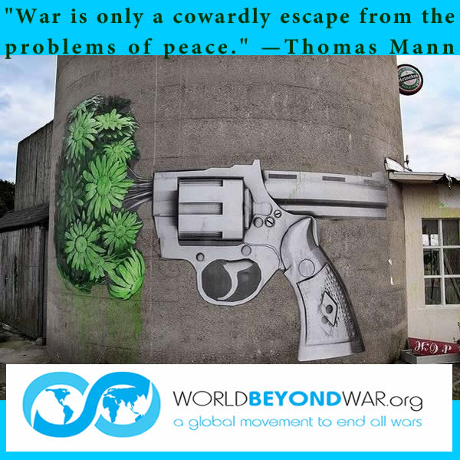

June 1. On this day in 1914, 80 militiamen refused to board a train as reinforcements for a U.S. invasion of Mexico.

June 2. On this day in 1939 a German ship full of desperate Jewish refugees sailed close enough to see the lights of Miami, Florida, but was turned away, as President Franklin Roosevelt had blocked all efforts in Congress to admit Jewish refugees. This is a good day on which to remember that justifications for wars are sometimes concocted only after the wars are over.

June 6. On this day in 1968 Robert F. Kennedy was murdered. This is a good day to study what happened.

June 10. On this day in 1963 President John. F. Kennedy spoke in favor of peace at American University.

June 12. On this day in 1982 one million people demonstrated against nuclear weapons in New York. This is a good day to oppose nuclear weapons.

June 14. On this day in 1945 the U.S. Supreme Court invalidated the compulsory flag salute for school children.

June 17. This is International Day for Mine Awareness and Assistance in Mine Action.

June 19. This is Juneteenth, marking the day in 1865 when previously enslaved people in Texas learned that they were free.

June 20. This is World Refugee Day.

June 23. This is United Nations Public Service Day.

June 25. On this day in 1918 Eugene V. Debs was arrested for speaking against war. Also on this day in 1945, the United Nations Charter was signed.

June 26. This is United Nations International Day in Support of Victims of Torture.

June 27. On this day in 1869 Emma Goldman was born. Also on this day in 1954 the CIA violently overthrew the government of Guatemala. This is a good day on which to advocate for the abolition of the CIA and of secret agencies.

June 28. On this day in 2009 a U.S.-backed coup overthrew the government of Honduras. This is a good day to work for the combination of the peace movement with the immigrants (refugees) rights movement.

July

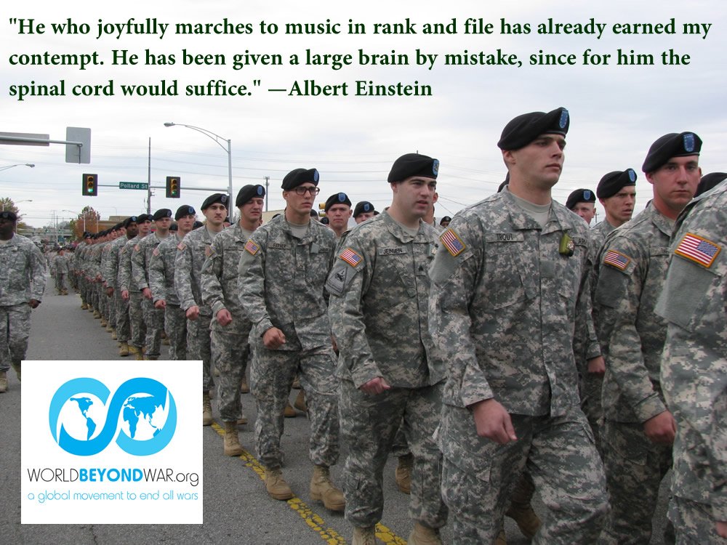

July 4. This is Independence From the United States Day. This is a good day for protest of local U.S. military bases around the world.

July 12. On this day in 1817 Henry David Thoreau was born. This is a good day to be civilly disobedient.

July 17. On this day in 1998, the Rome Statute was adopted establishing the International Criminal Court. This is a good day on which to push for Western powers to be made subject to its jurisdiction and for that jurisdiction to include the supreme crime of war.

July 18. This is Nelson Mandela International Day.

July 23. On this day in 1846 Henry David Thoreau went to jail for refusing to pay his war taxes. Also on this day in 2002, the cabinet of the British government held a meeting at 10 Downing Street, the minutes of which became known as the Downing Street Minutes. They revealed U.S. plans to go to war against Iraq and to lie about the reasons why. This is a good day to educate the world about war taxes and war lies.

July 29. On this day in 1923 No More War rallies were held in 23 countries.

July 30. This is International Day of Friendship. This is a good day to make or reconnect with a distant friend.

July 31. On this day in 1914 Jean Jaurès was assassinated.

August

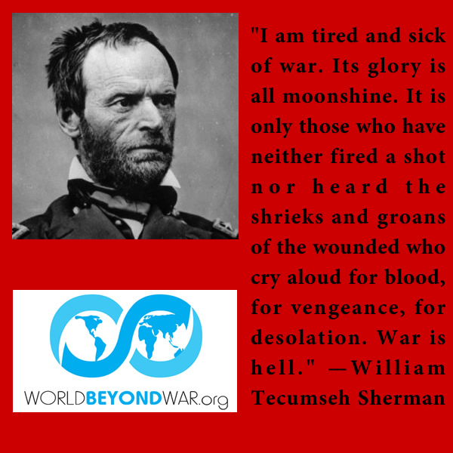

August 5. On this day in 1963 the U.S., USSR, and Great Britain signed a treaty banning nuclear testing in the atmosphere.

August 6. On this day in 1945 the U.S. dropped a nuclear bomb on Hiroshima, Japan, killing some 140,000 men, women, and children. President Truman went on the radio to justify this as revenge and lie that Hiroshima was a military base rather than a city. This is a very good day to oppose nuclear weapons.

August 9. On this day in 1945 the U.S. dropped a nuclear bomb on Nagasaki, Japan, killing some 65,000 men, women, and children. Also on this day in 1974 U.S. President Richard Nixon resigned in disgrace. U.S. warmaking was considerably scaled back for years to follow. This is a good day to work for an equal rule of law for all and governments accountable to people.

August 10. On this date in 1964, the U.S. Congress and President enacted the Gulf of Tonkin Resolution in response to the fraudulent Tonkin Gulf incident in which the Vietnamese allegedly committed an act of aggression against the U.S. ships that were attacking the coast of Vietnam. In reality, the attack did not occur. This is an appropriate day to educate the world about war lies.

August 13. On this day in 1964 Britain last used the death penalty.

August 14. On this day in 1947 India achieved independence from British rule without a war.

August 15. On this date in 1973, the U.S. conceded defeat and stopped killing Vietnamese, ending a war that had faced the military opposition of the Vietnamese and the activist opposition of much of the U.S. public and the world.

August 16. On this date in 1980 the Solidarity movement was organized in Poland that would go on to nonviolently overturn the government. This is a good day to tell someone to stop saying "resort to violence" and start saying "resort to nonviolence."

August 18. On this date in 1941, almost 4 months before the Japanese attack on Pearl Harbor, Winston Churchill met with his cabinet at 10 Downing Street. The meeting had some similarity to the July 23, 2002, meeting at the same address, the minutes of which became known as the Downing Street Minutes. Both meetings revealed secret U.S. intentions to go to war. In the 1941 meeting, Churchill told his cabinet, according to the minutes: "The President had said he would wage war but not declare it." In addition, "Everything was to be done to force an incident." This is a good date on which to discuss the impossibility of a good war.

August 19. On this day in 1953, the CIA overthrew Iran's democracy. This is a good day on which to contemplate the disastrous and never-ending consequences -- whether unforeseen or deemed unimportant -- that predictably result from violent injustice.

August 20. On this day in 1968 a Soviet invasion was met with nonviolent resistance in Czechoslovakia.

August 27. This is Kellogg-Briand Day. On this day in 1928, in what was the biggest news story of the year, the major nations of the world gathered in Paris, France, to sign the Kellogg-Briand Pact banning all war. The treaty remains on the books today. The day is increasingly being recognized and celebrated as a holiday.

August 28. On this day in 1963 Martin Luther King Jr. gave his "I have a dream" speech at the march on Washington.

August 29. This is the International Day Against Nuclear Tests.

September

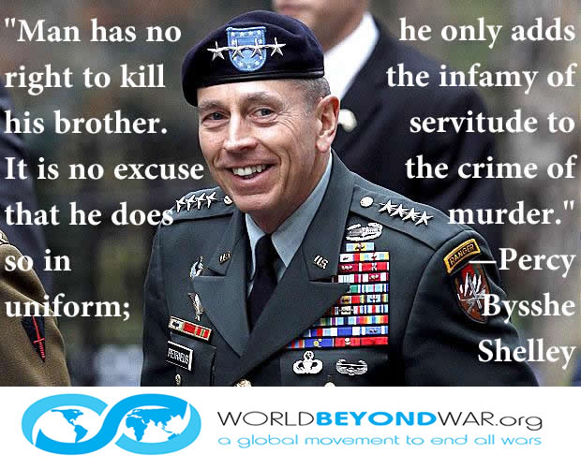

September 9. On this day in 1828 Leo Tolstoy was born. This is a good day to read his books.

September 11. On this day in 1973 the United States backed a coup that overthrew the government of Chile. Also on this day in 2001 terrorists attacked in the United States using hijacked airplanes. This is a good day to oppose violence and nationalism and revenge.

September 14. On this day in 2013, the United States agreed to eliminate Syria's chemical weapons in cooperation with Russia, rather than launching missiles into Syria. Public pressure had been instrumental in preventing the missile attacks. Although those attacks were presented as a last resort, as soon as they were blocked all sorts of other possibilities were openly acknowledged. This is a good day on which to refute the nonsensical claim that wars can never be stopped.

September 15. On this day in 2001, Congresswoman Barbara Lee cast the only vote against giving U.S. presidents a pass to wage wars.

September 17. This is Constitution Day in the United States. On this day in 1787 the U.S. Constitution was adopted and had not yet been blatantly violated. Also on this day in 1978 Egyptian President Anwar El Sadat and Israeli Prime Minister Menachem Begin signed the Camp David Accords. This is a good day on which to thank a diplomat for their service. This is a good day on which to back serious reforms for the U.S. Constitution.

September 18. On this day in 1924 Gandhi began a 21-day fast in a Muslim home, for Muslim-Hindu unity.

September 21. This is the International Day of Peace. Also on this day in 1963 the War Resisters League organized the first U.S. demonstration against the war on Vietnam. Also on this day in 1976 Orlando Letelier, a leading opponent of Chilean dictator Gen. Augusto Pinochet, was killed along with his American assistant, Ronni Moffitt, by a car bomb in Washington, D.C. -- the work of a former CIA operative. This is a good day to work for peace and to remember the victims of war.

September 26. This is the UN International Day for the Total Elimination of Nuclear Weapons. Also on this day in 1924 the League of Nations endorsed the Declaration of Rights of the Child.

October

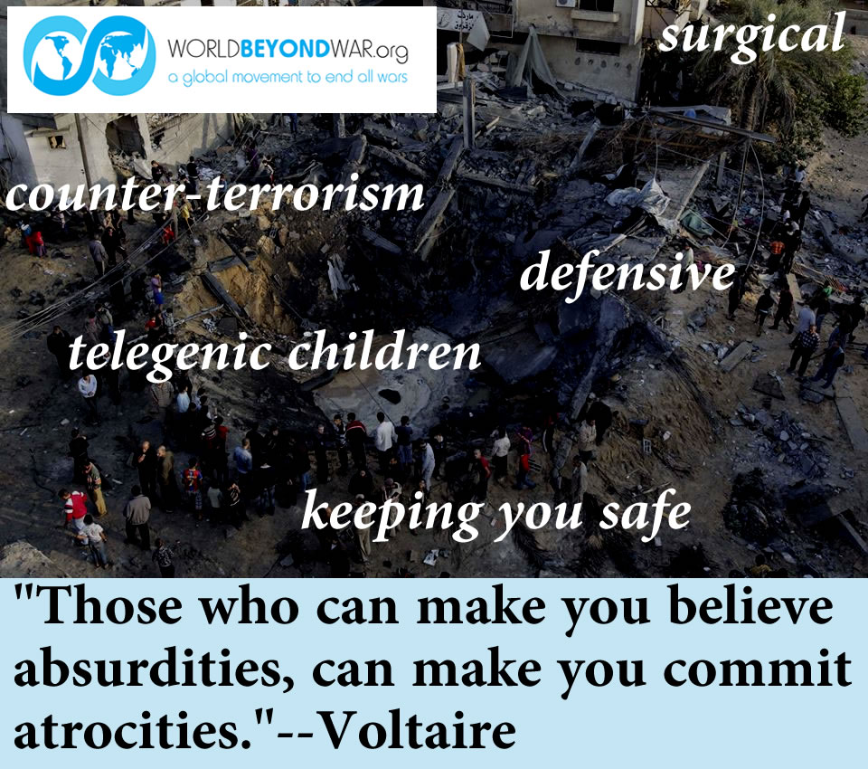

October 1. On this day in 1990, the United States backed an invasion of Rwanda by a Ugandan army led by U.S.-trained killers, and supported their attack on Rwanda for the next three-and-a-half years. This is a good day to remember that while wars cannot prevent genocides, they can cause them.

October 2. This is International Day of Non-Violence and the day on which Mohandas Gandhi was born in 1869.

October 7. On this day in 2001 the United States attacked Afghanistan and began possibly the longest lasting war in U.S. history. This is a good day on which to remember that wars are far more easily prevented than ended.

October 10. On this day in 1990, the daughter of the Kuwaiti ambassador to the United States lied to the U.S. Congress, as coached by the Hill and Knowlton public relations company, that Iraqi soldiers had taken babies out of incubators and left the babies to die. This fiction was used by President George H.W. Bush and members of Congress to justify the first Gulf War. Also on this day in 1991 Women in Black began regular Wednesday vigils against war in Belgrade, Serbia. Also on this day in 2002 Congress authorized President George W. Bush to attack Iraq.

The second Monday in October is Columbus Day, the day the native peoples of the Americas discovered European genocide. This is a good day on which to study history.

October 13. On this day in 1954 Mordechai Vanunu was born.

October 15. On this day in 1969, 2 million people participated in the first moratorium against the war on Vietnam.

October 16. On this day in 1934 the Peace Pledge Union was founded in Britain.

October 17. On this day in 1905 the Czar of Russia conceded many of the demands of a nonviolent resistance movement in Russia. This is a good day to study and practice nonviolence.

October 24. This is United Nations Day. This is a good day to push for democratization of the United Nations.

October 25. On this day in 1983 the U.S. Marines attacked the massive threatening leviathan of Grenada.

October 27. On this day in 1941, two months before the Japanese attack on Pearl Harbor, President Franklin Roosevelt gave a speech in which he falsely claimed that two U.S. ships attacked by German submarines had been innocent of engagement in the war, falsely claimed to have in his possession a Nazi map planning the conquering and division of South America, and falsely claimed to have a Nazi document that planned the elimination of all religion from the earth. This is a good day to study the impossibility of a good war.

October 28. On this day in 1962 Kennedy and Khrushchev agreed to de-escalate the Cuban missile crisis. This is a good day on which to remember that talking is preferable to bombing, especially with nuclear bombs.

November

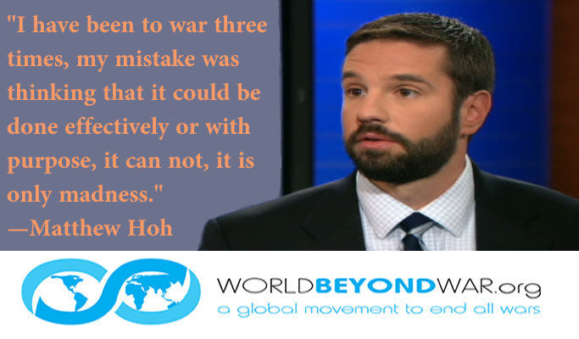

November 4. On this day in 1980, Ronald Reagan was elected U.S. president after secretly and treasonously using George H.W. Bush and William Casey to persuade Iran not to release U.S. hostages while Jimmy Carter was still president.

November 5. On this day in 1855 Eugene V. Debs was born. Also on this day in 1968 Richard Nixon was elected U.S. president after secretly and treasonously sending Anna Chennault to sabotage Vietnam peace talks, campaigning on a nonexistent secret plan for peace, and actually planning to continue the war, as he did once elected. This is a good day to think about who our real leaders are.

November 6. This is the International Day for Preventing the Exploitation of the Environment in War and Armed Conflict.

November 9. On this day in 1989 the Berlin Wall began to be demolished, symbolizing the ending of the Cold War. This is a good day to remember how fast change can come and how available peace is.

November 11. This is Armistice Day. At 11:00 on this 11th day of the 11th month World War I ended in 1918 -- a scheduled end to the war, with the killing and dying pointlessly continuing right up to that moment. This is a good day to ring bells and work for peace.

November 13. On this day in 1974 U.S. anti-nuclear activist Karen Silkwood was killed.

November 19. On this day in 1915 Joe Hill was executed but never died.

November 22. On this day in 1963, President John F. Kennedy was murdered. This is a good day on which to study what happened and perform a related play.

November 29. This is International Day of Solidarity with the Palestinian People.

November 30. On this day in 1999, a wide coalition of activists nonviolently shut down the WTO meetings in Seattle, Washington. This is a good day for coalition building.

December

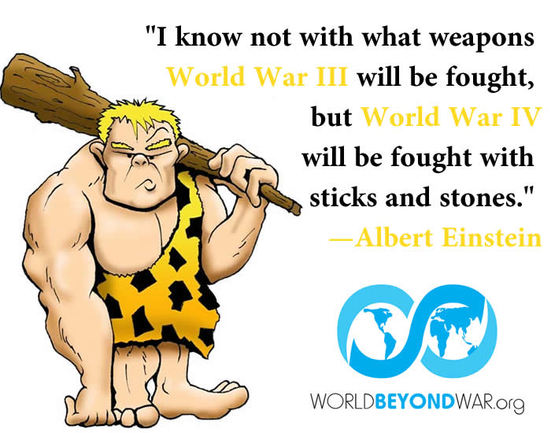

December 1. This is Military Abolition Day and Prisoners for Peace Day. On this day in 1948 Costa Rica abolished its military. This is a good day to dedicate to war abolition.

December 2. On this day in 1914 Karl Liebknecht cast the only vote against war in the German parliament.

December 3. On this day in 1997 the treaty banning land mines was signed. This is a good day on which to demand that the remaining few holdout countries sign it.

December 7. On this day in 1682 the Great Law banned war in Pennsylvania. Also on this day in 1941 the Japanese bombed Pearl Harbor just as Roosevelt's cabinet expected.

December 8. On this day in 1941 Congresswoman Jeanette Rankin cast the only vote against U.S. entry into World War II.

December 10. This is Human Rights Day.

December 14. This is Bill of Rights Day, the day in 1791 on which the U.S. Bill of Rights was ratified. This is a good day to attempt to make real, and to expand and update, some of those rights.

December 17. On this day in 2010, Mohamed Bouazizi's self-immolation in Tunisia launched the Arab Spring. This is a good day to organize nonviolent resistance to injustice.

December 20. This is International Human Solidarity Day, as well as the day in 1989 that the United States attacked Panama.

December 21. On this day in 1940, two weeks shy of a year before the Japanese attack on Pearl Harbor, China's Minister of Finance T.V. Soong and Colonel Claire Chennault, a retired U.S. Army flier who was working for the Chinese and had been urging them to use American pilots to bomb Tokyo since at least 1937, met in U.S. Treasury Secretary Henry Morgenthau's dining room to plan the firebombing of Japan. Morgenthau said he could get men released from duty in the U.S. Army Air Corps if the Chinese could pay them $1,000 per month. Soong agreed. This is a good day to consider that wars between two armed parties, like the Tango, take two.

December 22. On this day in 1847, Congressman Abraham Lincoln challenged President James Polk to provide evidence that Mexico had actually attacked the United States, rather than the other way around. Polk never did, but he had indeed launched a war and stolen half of Mexico, incorporating it into the United States.

December 23. On this day in 1947 President Truman pardoned 1,523 of 15,805 World War II draft resisters.

December 25. This is Christmas, traditionally a holiday of peace for Christians. On this day in 1776, George Washington led a surprise night crossing of the Delaware River and pre-dawn raid on unarmed hung-over-from-Christmas troops still in their underwear -- a founding act of violence for the new nation. Also on this day in 1875 Jessie Wallace Hughan, founder of the War Resisters League, was born. Also on this day in 1914, soldiers on both sides of the trenches of World War I took part in a Christmas Truce. This is a good day to work for peace on earth.

December 26. On this day in 1874 Norman Angell was born.

December 28. On this day in 1991 the Philippines ordered the United States out of its country. This is a good day on which to demand the closure of foreign bases.

December 29. On this day in 1890 in the Wounded Knee Massacre, the U.S. military killed 130-250 Sioux men, women, and children. This is a good day on which to marvel at how nations like Germany and Japan memorialize their worst history but the United States ignores its bloody origins and traditions.

Please send additions and corrections to this calendar to info@worldbeyondwar.org

